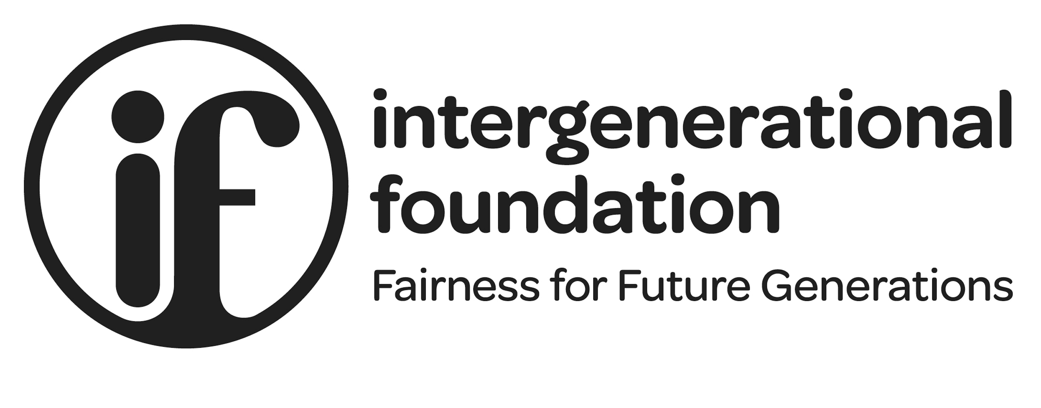

PRESS RELEASE

Young people, already struggling, to be further clobbered by Covid

The well-being of young people was already in sharp decline even before the Covid-19 crisis struck a fresh hammer blow to their future prospects, new research from the Intergenerational Foundation reveals today.

The latest Index of Wellbeing from IF (www.if.org.uk) overturns the common assumption of ever-improving living standards by showing that the current generation of 20-somethings now has a worse quality of life than their parents’ generation.

“It is no surprise that the Millennial generation are struggling. They are saddled with student debt, low wages, high housing costs and poor career progression,” said David Kingman, the report’s author. “And now Covid is going to multiply those effects by throwing hundreds of thousands of young people out of their jobs and out of their flats. The packhorse generation is having an unsustainable and unfair burden put on its shoulders”.

Official data out this week showed that three quarters of a million jobs have been lost since the economy was shut down, and IF suspects that the young will be, as usual, the hardest hit. Younger people tend to work in sectors such as travel and hospitality – the sectors hit worst by the government’s reaction to Covid-19.

The IF Index, which analysed 17 statistical indicators for 18 to 26 year-olds, starting in 1991 and running through until 2017/18, found that today’s twentysomethings have 8% lower overall scores for “wellbeing”, when broken down to the wellbeing areas: economic, work, social, physical and mental health, and belonging.

The largest deterioration was found in the social wellbeing indicator – which fell by more than 70% during the period. This was largely because of a decline in the “relationship status” indicator. In 1991, 36% of young adults were either married or living as a couple. Fast forward to 2017/18 and just 13% of young adults were in settled relationships, equivalent to a decline of almost two-thirds. In previous wellbeing research, having successful intimate relationships has consistently been shown to be one of the most significant variables for predicting positive wellbeing. The quality of relationships that today’s twentysomethings have with their family also appears to be under strain, falling from 34% in 1991 to 16% in 2017/18.
.../2

2/...

Ashley Seger, IF Co-founder, comments, “Policy-makers must wake up to the emotional damage being done to younger generations. The economic deterioration in young people’s prospects is now well documented but the cracks appearing in young people’s relationships with their families and closest relationships is are deeply troubling. And the Covid-induced lockdown is going to make matters dramatically worse.”

The research also highlighted how the living standards of young adults have stagnated during this period, as the average working member of this age group was earning only 1% more in real terms than their counterpart was in 1991 despite being much more likely to have a university degree.

IF is demanding a “New Deal for the Young” which would rip up the existing tax system and re-position it to be fairer to the young and to the environment. IF’s figures show that the government could raise up to £50 billion a year through taxes on unearned income and wealth, comfortably enough to allow it to repay all student debt and allow young people to enjoy a free university education. Older generations are sitting on trillions of pounds of untaxed wealth, mainly in their houses, while young people struggle to even get on the housing ladder. The situation is unfair and untenable, the think-tank says.

On a more positive note, “Belonging” wellbeing has seen a dramatic improvement since an all-time low in 2013/14, thanks to much higher democratic participation due to the EU Referendum and General Elections in 2015 and 2017, the report concludes.

- ends -

Notes to Editors:

- The research, by the Intergenerational Foundation, analysed five wellbeing areas – social, economic, physical and mental health, work and belonging – over the period from 1991 to 2017/18.

- 17 indicators from the British Household Panel Survey and Understanding Society were chosen, as previous research has suggested that they each have a significant bearing on wellbeing.

- The data were standardised and transformed so that an increase in a score always represents a decrease in wellbeing.

- The Intergenerational Foundation is a non-party-political charitable think tank funded by no-strings donations.

- TV, radio and print interviews are available with Ashley Seager, IF Co-founder, and report author, David Kingman:

Please contact Liz Emerson on 07971 228823, liz@if.org.uk to arrange.

